**MIDDLETON CHENEY FOOTBALL CLUB**

**ANNUAL GENERAL MEETING**

**1992**

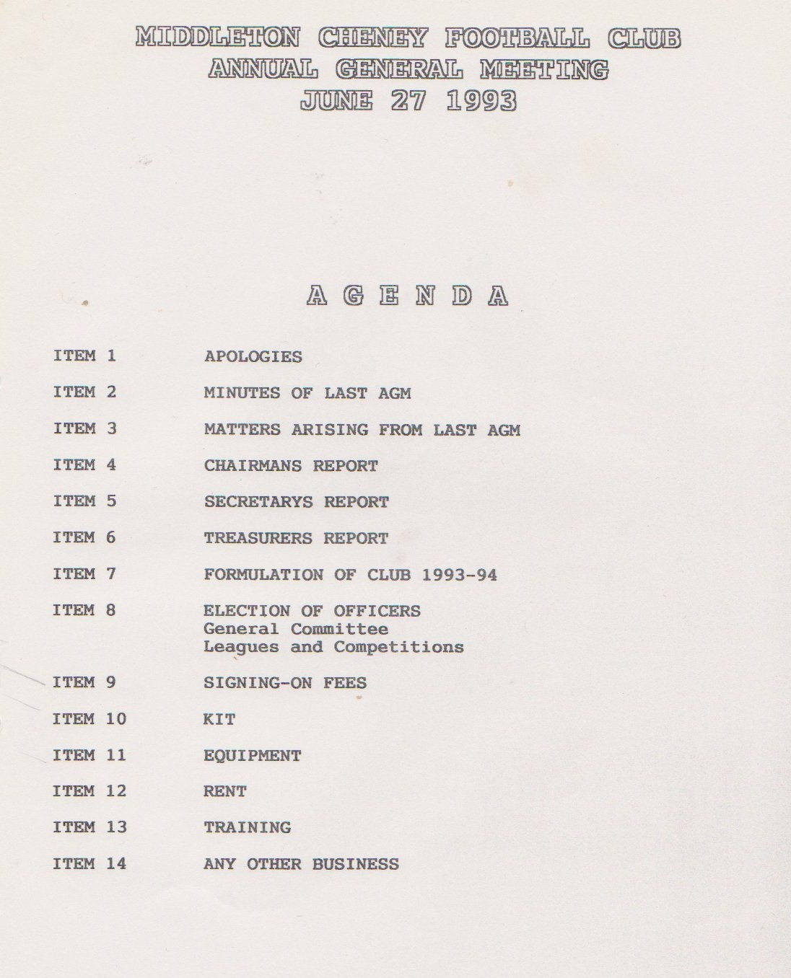

**Continued**

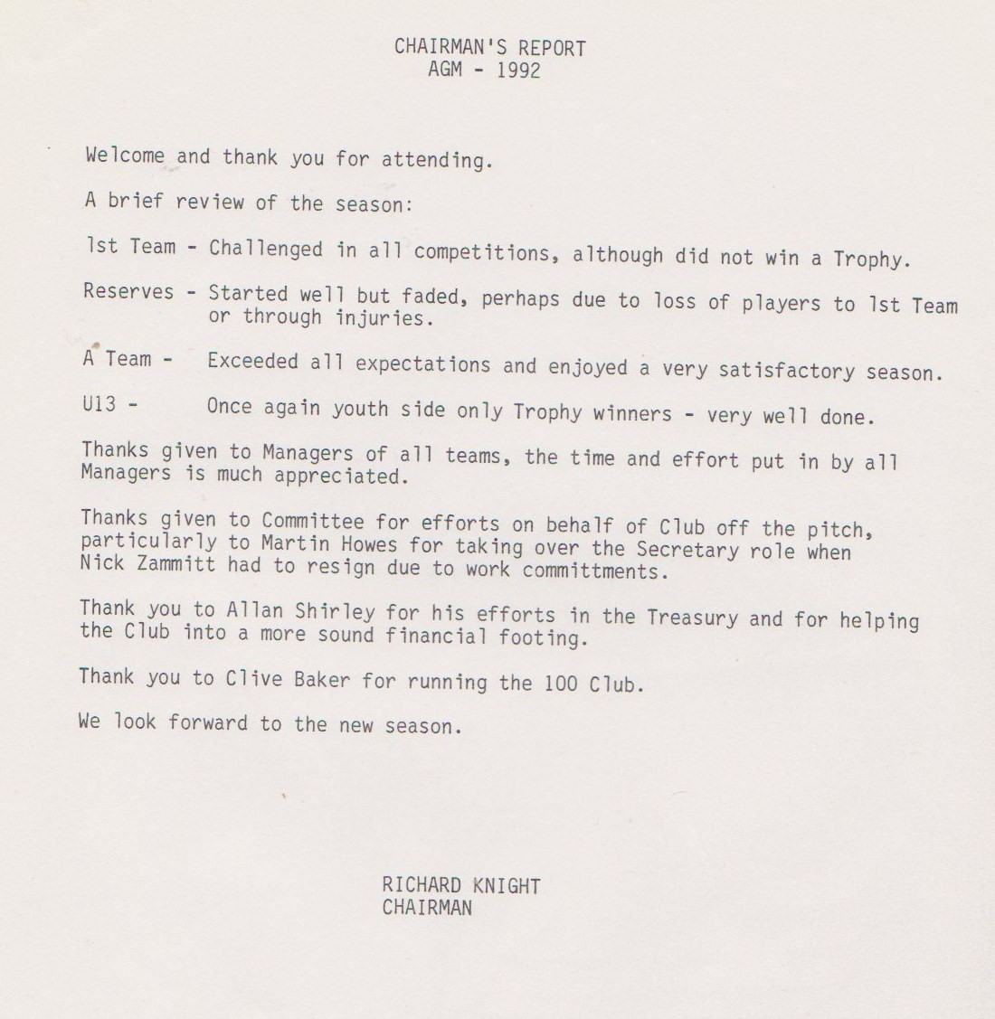

**Continued**

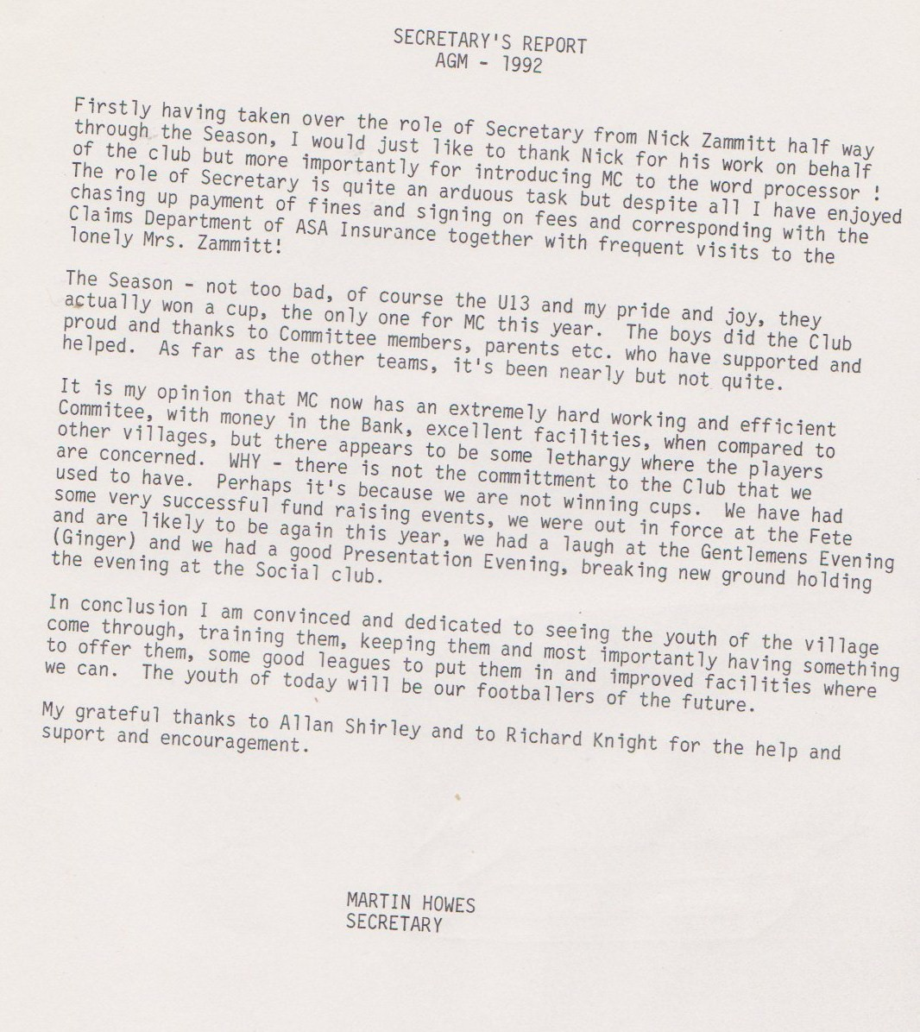

**Continued**

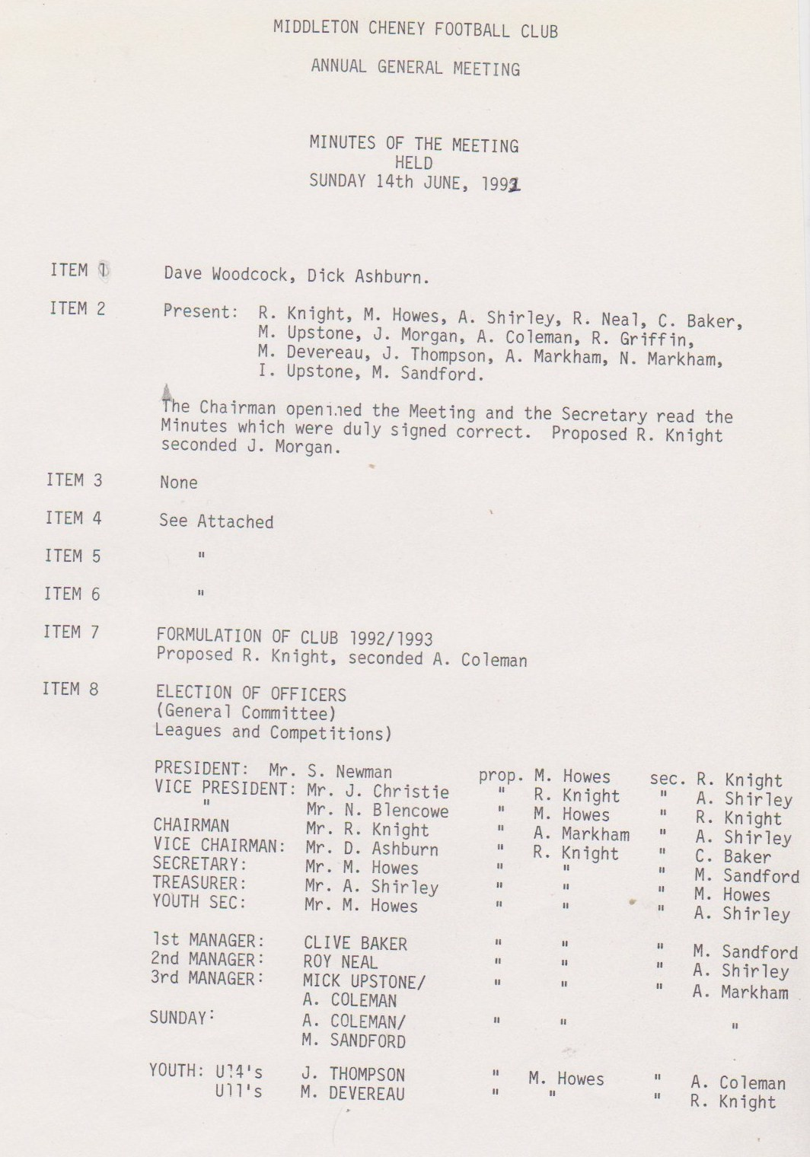

**Continued**

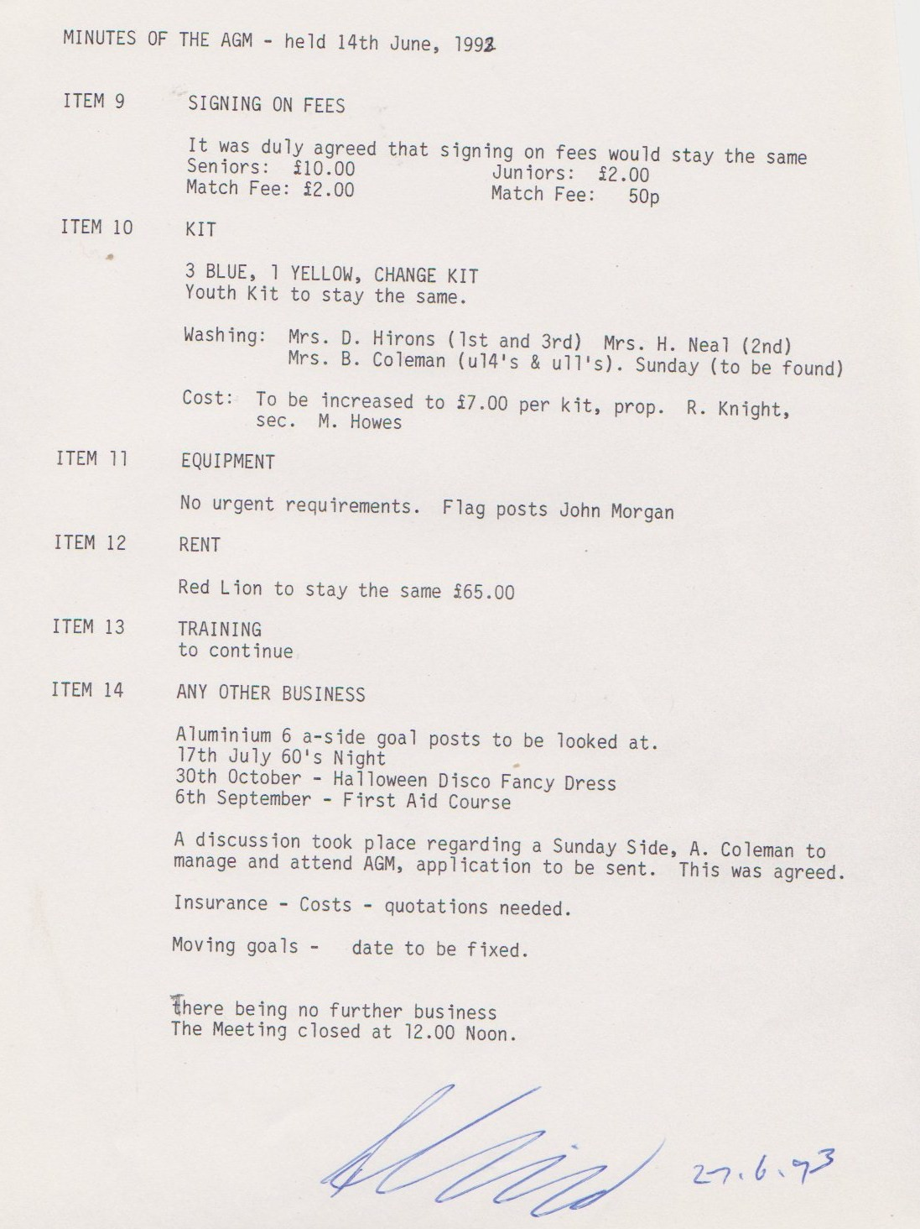

**General Committee Meeting**

**November 7th 1992**

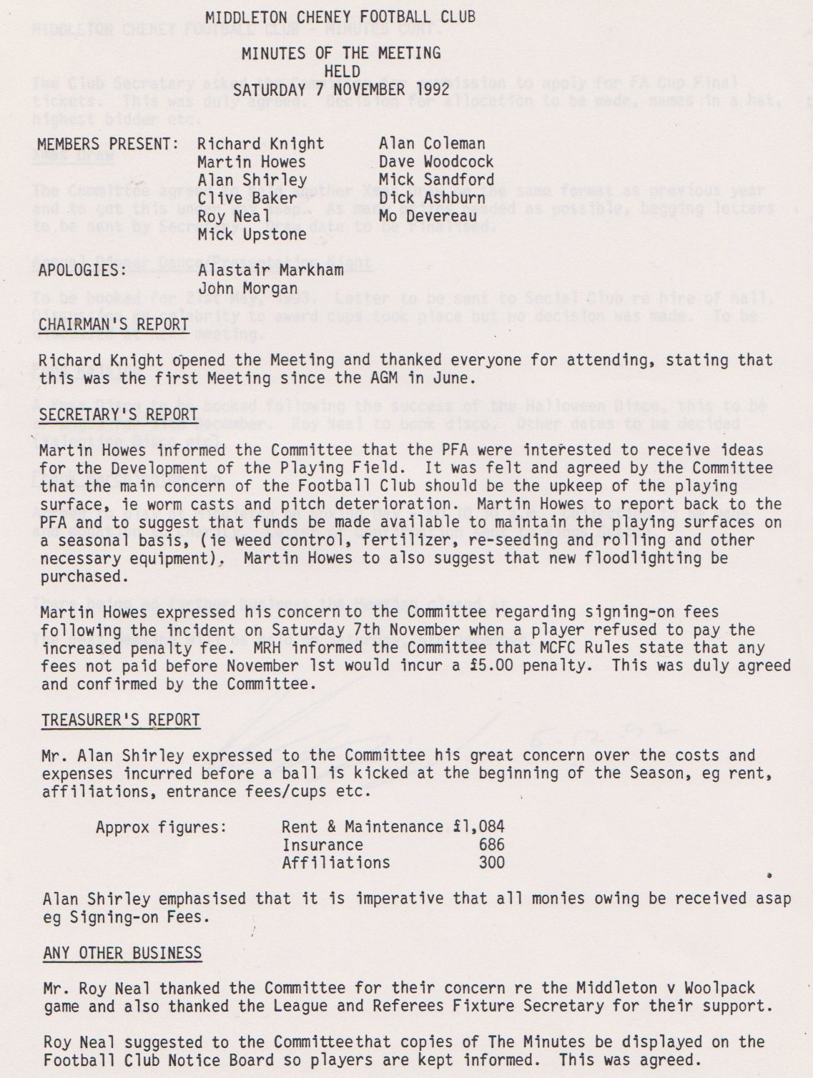

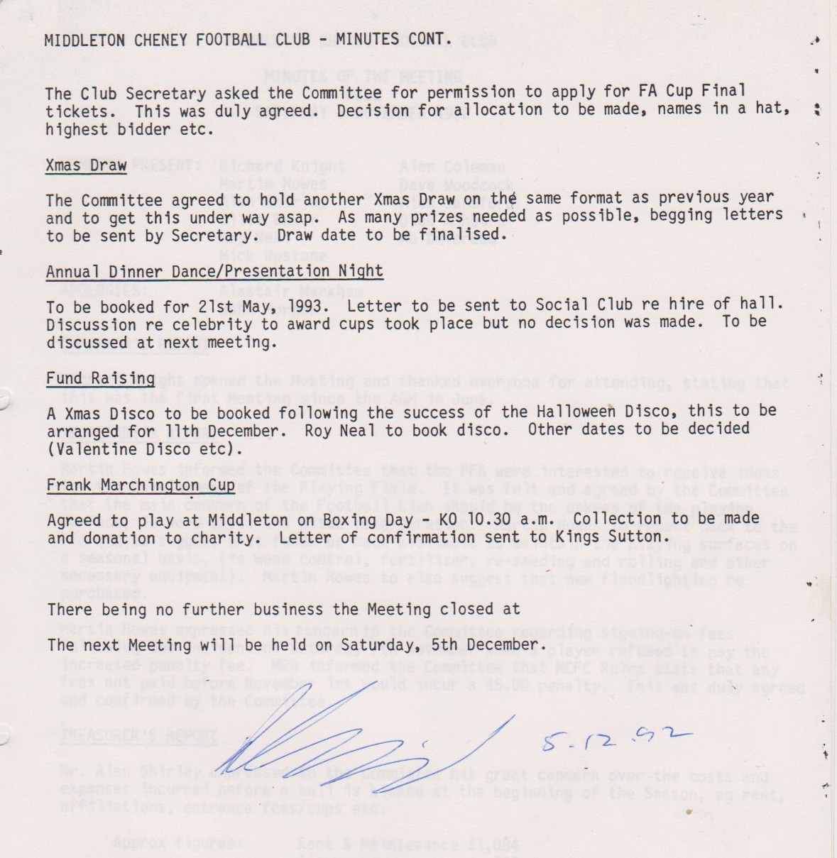

**General Committee Meeting**

**December 5th 1992**

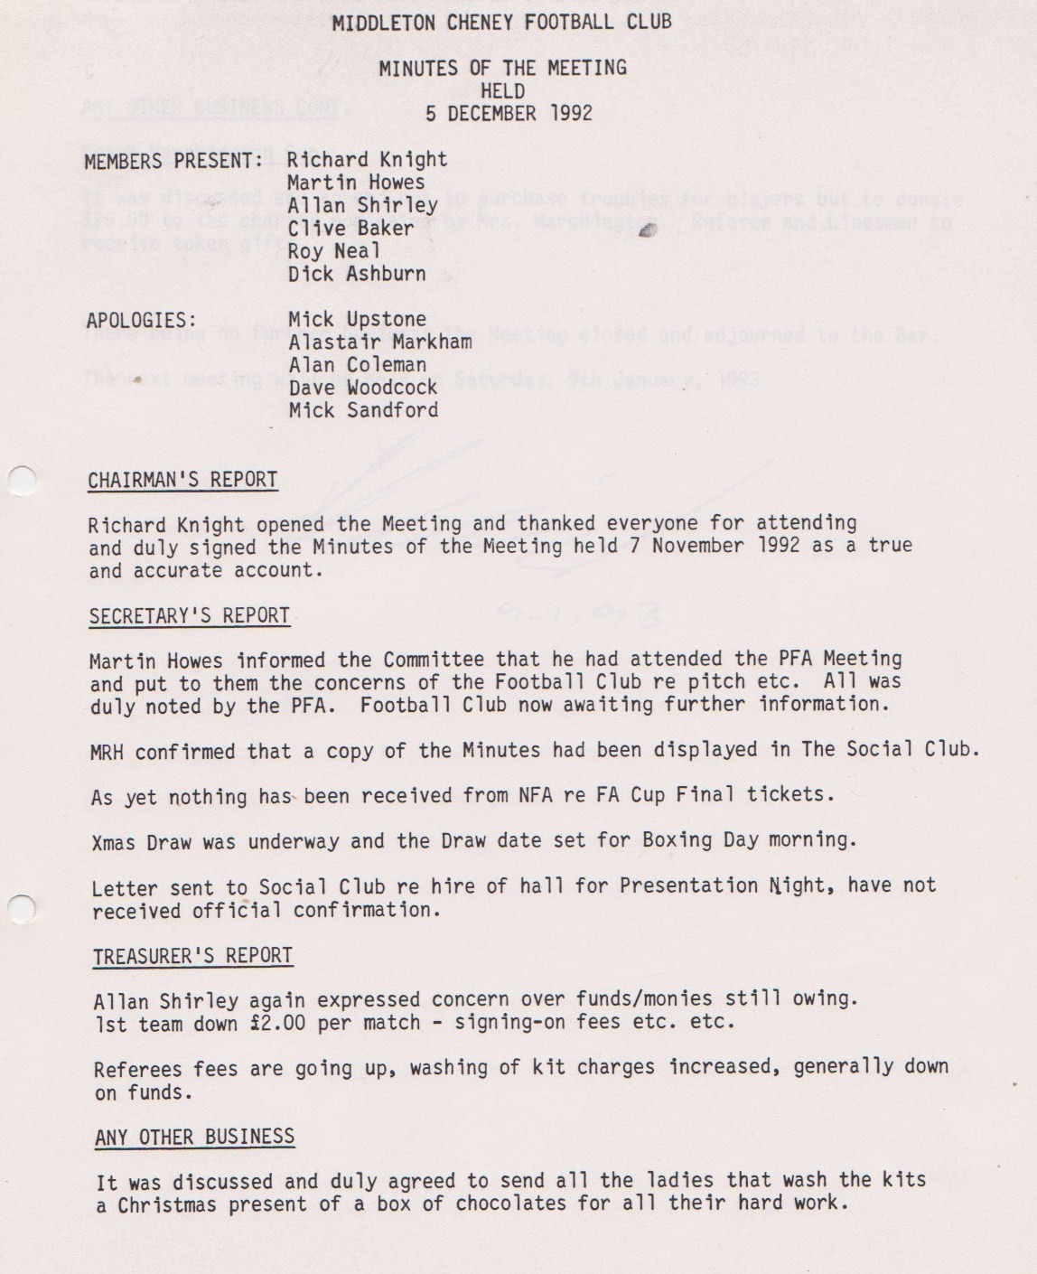

**Continued**

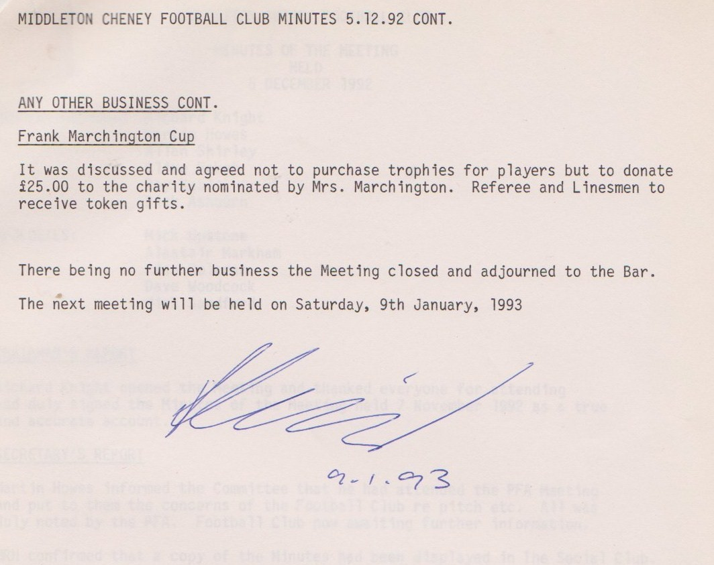

**General Committee Meeting**

**January 9th 1993**

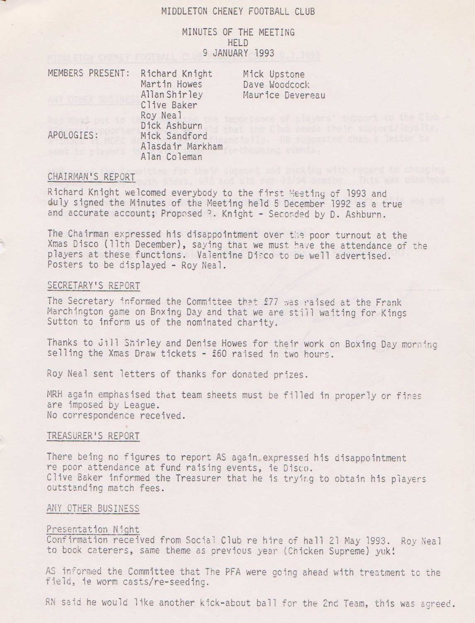

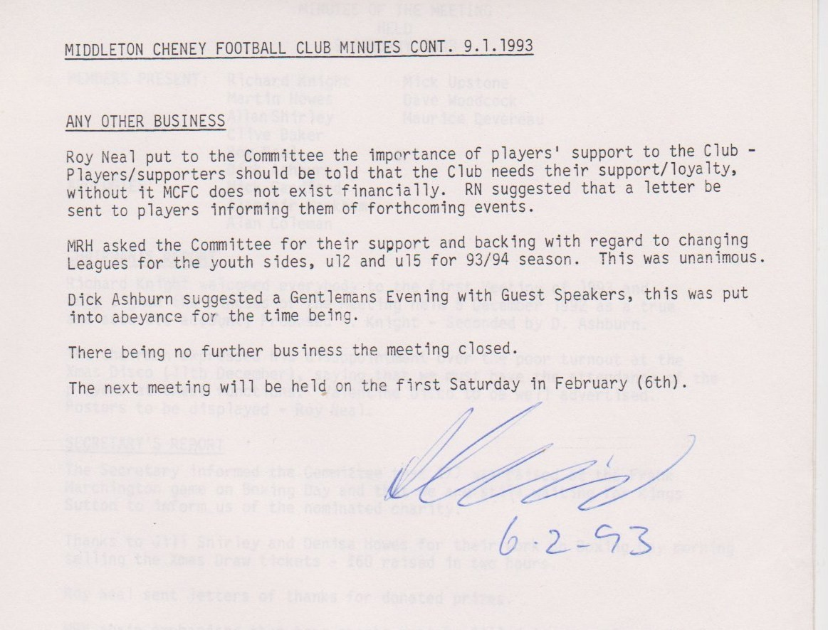

**General Committee Meeting**

**February 6th 1993**

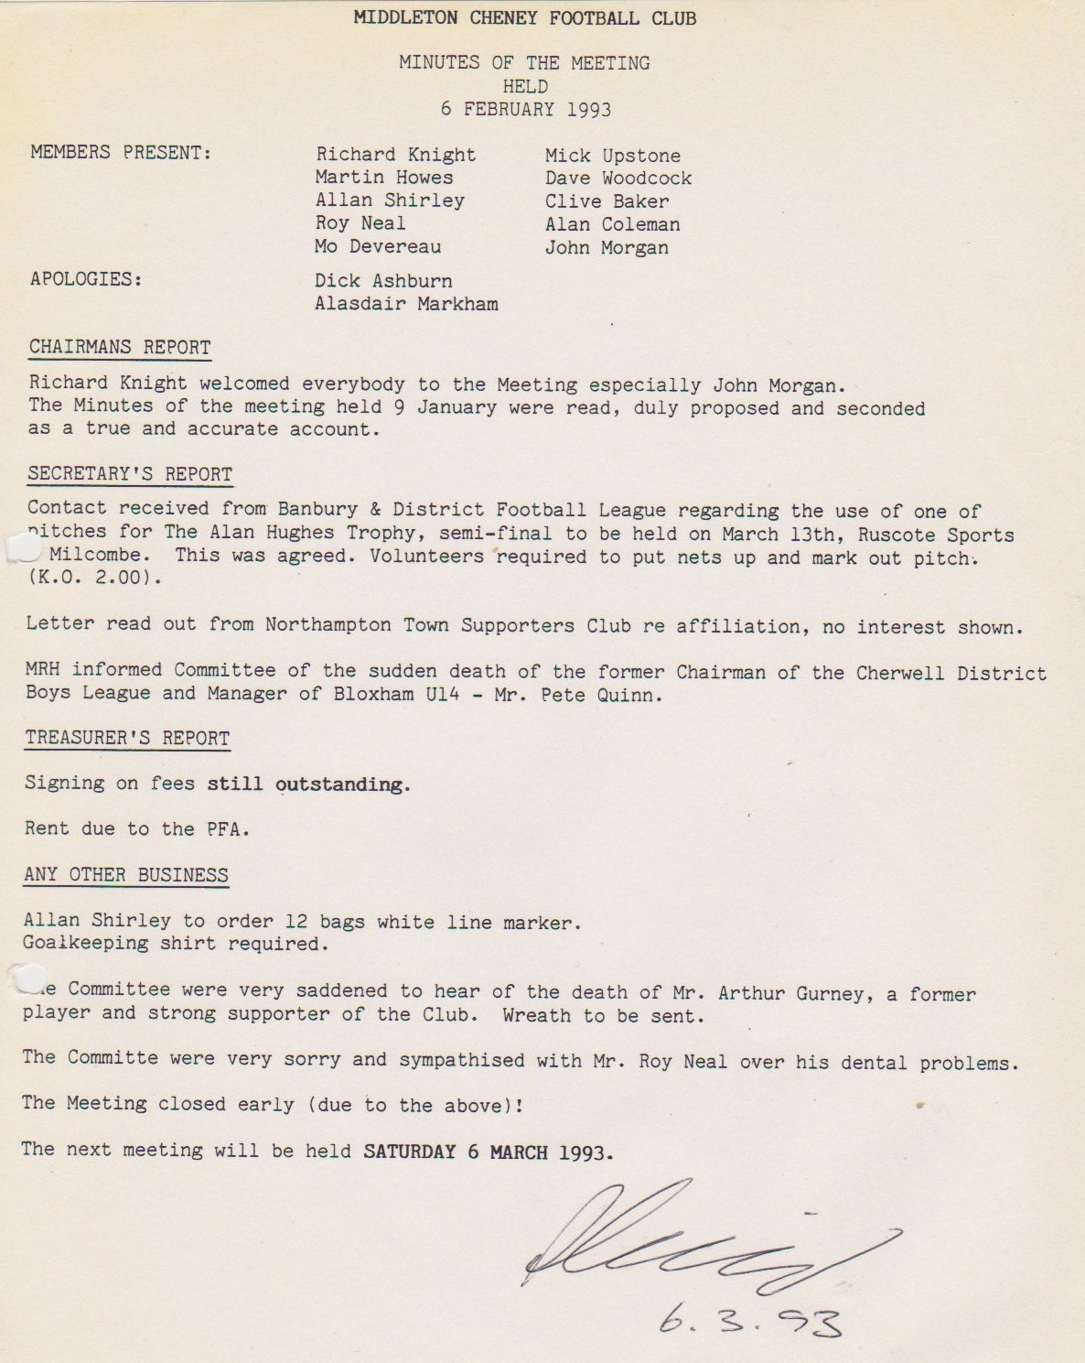

**General Committee Meeting**

**March 6th 1993**

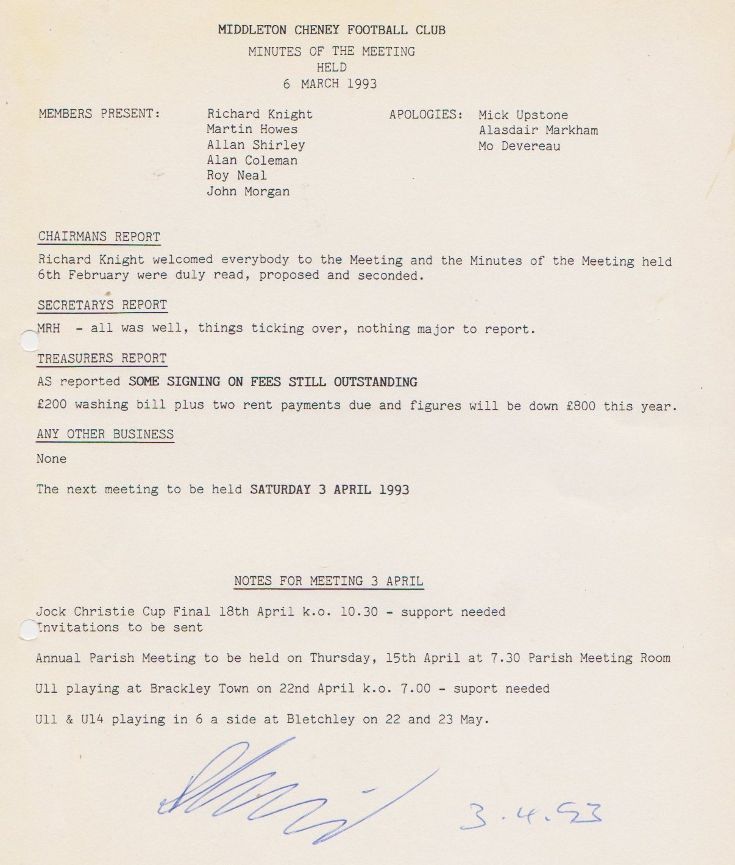

**General Committee Meeting**

**April 3rd 1993**

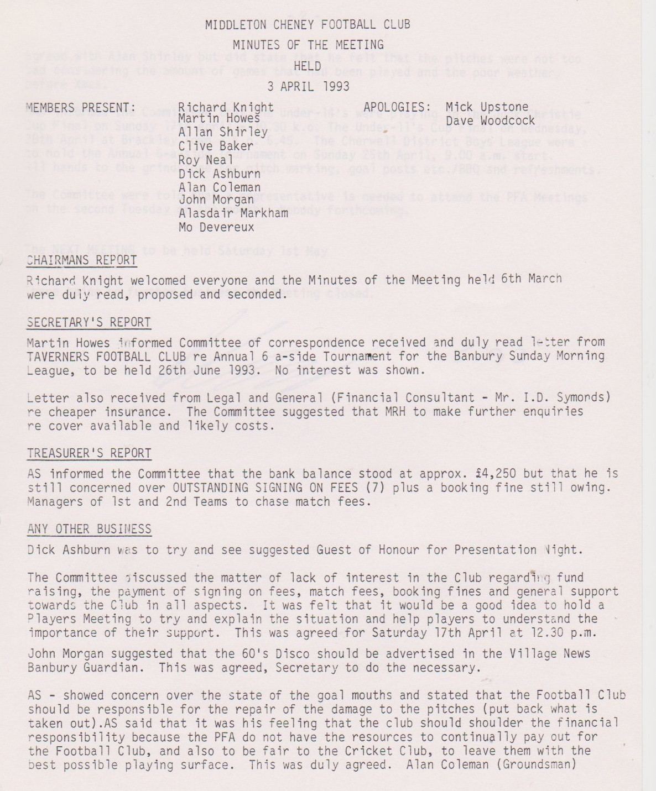

**Continued**

